Ministry of Health of Ukraine
Kharkiv National Medical University
ІІ Medical Faculty
Department of Phthisiology and Pulmonology
Branch of knowledge 22 «Healthcare»
Specialty 222 «Medicine»
Educational and professional program «Medicine»
Second master's level of higher education

SYLLABUS OF ACADEMIC DISCIPLINE
Urgent Problems of Pulmonology
Approved  by the Counsil of the Department  of Phthisiology and Pulmonology  Protocol  “28” August 2020 № 13  Head of the Department  _______________ O.S. Shevchenko  “_____”__________________ 20___ |  | Approved by  Methodological Commission of KNMU on the problems of professional training of a therapeutic profile  Protocol  “____”________________20___ № ___  Head  ____________ P.G. Kravchun  “_____”________________20____

Kharkiv – 2020
Place of practical training: classrooms of the department of Phthisiology and Pulmonology of Kharkiv National Medical University on the bases: Municipal Nonprofit Enterprise of the Kharkiv Regional Council "Regional TB Dispensary No. 1" (Newtona str., 145), Municipal Nonprofit Enterprise of the Kharkiv Regional Council «Regional Tuberculosis Hospital No. 1» (Novo-Bavarsky av., 2), State Institution of Health Care «Regional Tuberculosis Hospital No. 3» (Pirogova str., 8)
Time of practical classes: 08:00-12:15.
Course developers:
Olga Stanislavna Shevchenko – Head of the Department, MD, Prof.
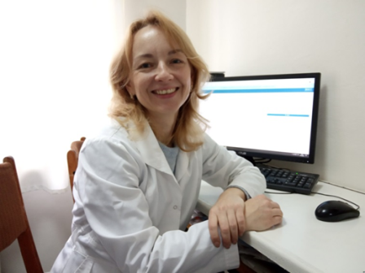
Irina Anatoliyivna Ovcharenko – Head Teacher of the Department, assistant
Teachers
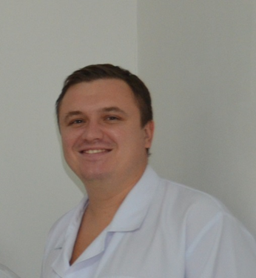 | Dmytro Olexandrovich Butov – MD, Prof., Responsible for students’ scientific work  Address: Pirogova str., 8
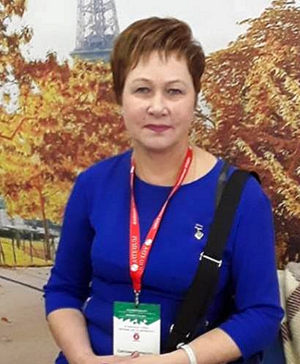 | Svitlana Leonidivna Matveyeva – PhD., Associate Prof., Responsible for the medical work of the department  Address: Newtona str., 145
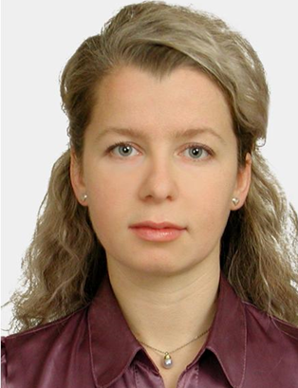 | Olexandra Ivanivna Choporova – PhD, Assistant, Responsible for scientific work of the Department  Address: Novo-Bavarsky av., 2
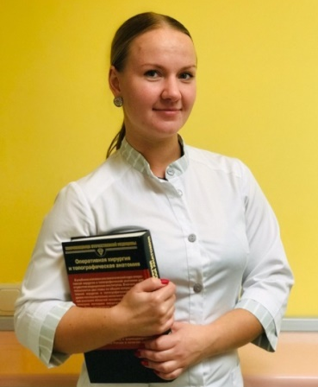 | Olga Olexandrivna Hovardovska –Assistant, Responsible for the submission of information about the department on electronic resources  Address: Novo-Bavarsky av., 2
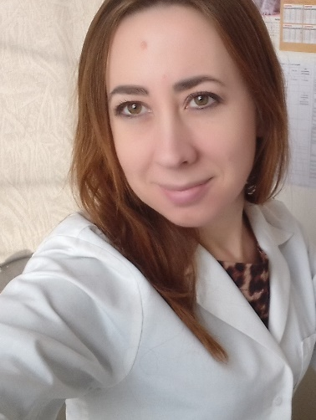 | Olga Mykolaivna Svets  Address: Newtona str., 145

9th semester 2020/2021
Course annotation:
Course includes information about diagnosis, treatment and prophylaxis of the most common lung disease and emergency conditions which may complicate them.
Credits – 3
Hours – 90.
Hours for full-time study: classroom hours – 20
self-study hours – 70
Practical classes 20 hours.
Control: credit.
Aim: mastering basic knowledge of epidemiology, etiology, pathogenesis, clinic, diagnosis, treatment, prevention and emergency conditions in pulmonology
Tasks:
- formation of students' ability to determine main symptoms and syndromes of lung diseases;
- formation of students' ability to determine risk factors for lung diseases;
- students' mastering of modern methods of lung diseases diagnostics;
- formation of students’ ability to diagnose complications of lung diseases and provide care in emergency conditions.
Status of discipline: elective course
Format of discipline: mixed
Teaching methods: presentations, videos, guidelines, workbooks, lectures, case histories, X-rays etc.
Moodle link: http://31.128.79.157:8083/enrol/index.php?id=876
Literature
1. Harryes A.TB. Clinical manual for South East Asia/ A.Harryes, D. Maner, M. Uplecar – Biella: WHO, 1997 – 145 p. 1. Principles of Harrison’s internal medicine, self-assessment and board review 18th edition /Edited by Charles Wiener etc. - The McGraw-Hill Professional. – 2012. – 514 p.
2. Board review from Medscape. Case-based internal medicine self-assessment questions / Editor-in-Chief David C. Dale. - WebMD. – 2005. – 592 p.
3. Kaplan Medical USMLE Step 2 Clinical Knowledge Qbook, 5th edition/ Edited by Kaplan inc. – Kaplan Publishing. – 2011. - 540 p.
4. Harrison's principles of internal medicine, 18th Edition / Edited by Dan Longo, Anthony S. Fauci etc. - The McGraw-Hill Professional. – 2011. - 4012 p.
5. Davidson’s Principles and Practice of medicine, 21st edition / Edited by Nick R. Colledge, Brian R. Walker, Stuart H. Relston. - Churchill Livingstone – 2010. – 1376 p.
Discipline prerequisites and core requisites: integrates with disciplines: microbiology, pathological anatomy, pathological physiology, propaedeutics of internal medicine, internal medicine, radiology, pharmacology, epidemiology and hygiene, public health and health management.
Results of education:
1. The ability to make a diagnosis.
1.1. In the health care institution, its subdivisions and among the population:
• Be able to identify and record the leading clinical symptom or syndrome by making an informed decision, using the preliminary data of the patient's history, the data of the physical examination of the patient, knowledge about the person, his organs and systems, adhering to the relevant ethical and legal norms.
• To be able to make the most probable or syndromic diagnosis by making an informed decision, by comparing with the standards, using the preliminary data of the patient's history and the patient's examination data, based on the leading clinical symptom or syndrome, using knowledge about the person, his organs and systems, adhering to the appropriate ethical and legal standards.
1.2. In a health care institution, its subdivisions:
• To prescribe laboratory and / or instrumental examination by making an informed decision based on the most probable or syndromic diagnosis, according to standard schemes, using knowledge about a human, organs and systems, ethical and legal norms.
• Carry out differential diagnosis of the disease by making an informed decision, according to a certain algorithm, using the most probable or syndromic diagnosis, data from laboratory and instrumental examination, knowledge about human, organs and systems, ethical and legal norms.
• Making a preliminary diagnosis by making an informed decision and logical analysis, using the most probable or syndromic diagnosis, data from laboratory and instrumental examination of the patient, conclusions of differential diagnosis, knowledge about a human, organs and systems, ethical and legal norms.
2. Skills in collecting patient information
Collect data on patient complaints, disease history, life history (including occupational history), in the conditions of a health care institution, its subdivision or at a patient's home, using the results of an interview with a patient, according to the standard patient survey scheme.
Under any circumstances (in a healthcare institution, its subdivision, at the patient's home, etc.), using knowledge about a human, organs and systems, according to certain algorithms:
• collect information about the general state of the patient (consciousness, constitution), perform examination of the skin, subcutaneous fat layer, palpation of lymph nodes, thyroid and mammary glands;
• examine the state of the cardiovascular system (examination and palpation of the area of ​​the heart and superficial vessels, determination of the percussion boundaries of the heart and blood vessels, auscultation of the heart and blood vessels)
• examine the state of the respiratory system (examination of the chest and upper respiratory tract, palpation of the chest, percussion and auscultation of the lungs);
• examine the state of the abdominal organs (examination of the abdomen, palpation and percussion of the intestines, stomach, liver, spleen, palpation of the pancreas, kidneys, pelvic organs, digital examination of the rectum);
• examine the condition of the musculoskeletal system (examination and palpation)
• examine the state of the nervous system ...
• examine the state of the genitourinary system ...
3. Ability to assess the results of laboratory and instrumental research
To evaluate information in the healthcare institution, its subdivision, applying a standard procedure, using knowledge about a human, organs and systems, based on the results of laboratory and instrumental studies.
4. Ability to determine the principles of the treatment of diseases
Prescribe the treatment (conservative, surgical) of the disease, using knowledge about a human, organs and systems, ethical and legal norms, by making an informed decision on existing algorithms and standard schemes.
5. Ability to diagnose emergency conditions
Making a diagnosis by making an informed decision and assessing a person's condition, under any circumstances (at home, on the street, in a health care institution, its subdivision), in conditions of lack of information and limited time, using standard methods of physical examination and available disease history, knowledge of the human, organs and systems, adhering to the relevant ethical and legal norms.
6. Ability to determine the tactics of providing emergency medical care
Determine the tactics of providing emergency medical care, under any circumstances, using knowledge about a human, organs and systems, ethical and legal norms, by making an informed decision based on the diagnosis of an emergency in a limited time using standard schemes.
7. Skills in providing emergency medical services help
Provide emergency medical care, under any circumstances, using knowledge about a human, organs and systems, adhering to the appropriate ethical and legal norms, by making an informed decision, based on the diagnosis of an emergency in a limited time, according to certain tactics, using standard schemes.
8. Skills of performing medical procedures
Perform medical manipulations based on a preliminary clinical diagnosis and / or indicators of the patient's state, using knowledge about a human, organs and systems, ethical and legal norms, by making an informed decision and using standard techniques.
9. The ability to determine the required work and rest regime in the treatment
Determine the necessary mode of work and rest in the treatment of a disease in a healthcare institution, at home with a patient on the basis of a preliminary clinical diagnosis, using knowledge about a human, organs and systems, ethical and legal norms, by making an informed decision on existing algorithms and standard schemes
10. Ability to determine nutritional therapy in the treatment
Determine the necessary therapeutic nutrition in the treatment in a health care institution, at home with a patient on the basis of a preliminary clinical diagnosis, using knowledge about a human, organs and systems, ethical and legal norms, by making an informed decision on existing algorithms and standard schemes.
11. Ability to maintain medical records
In a health care institution, its subdivisions:
Maintain medical documentation for the patient and the population using standard technology, based on regulatory documents.
12. Ability to carry out sanitary and hygienic and preventive measures
12.1. To form, in the conditions of a health care institution, its subdivisions in production, using a generalized procedure for assessing a person's health, knowledge about a human, organs and systems, ethical and legal norms, by making an informed decision, among the assigned contingent of the population:
• dispensary groups of patients;
• groups of healthy people related to dispensary observation.
12.2. Implement a system of anti-epidemic and preventive measures, in the context of a health care institution, its subdivisions based on data on the health status of certain population groups and on the presence of environmental impact on it, using existing methods, within the framework of primary health care to the population
12.3. Organize secondary and tertiary prevention among the population, using a generalized procedure for assessing the state of human health (screening, preventive medical examination), knowledge about a human, organs and systems, ethical and legal norms, by adopting a reasoned decision, in a healthcare institution, in particular:
• form dispensary observation groups;
• organize medical and recreational activities differentiated from the group of medical examination
13. Ability to plan preventive and anti-epidemic measures for infectious diseases
To plan measures to prevent the spread of infectious diseases in the conditions of a health care institution, its subdivisions, based on the results of an epidemiological examination of foci of infectious diseases, epidemiological analysis, using existing preventive and anti-epidemic methods.
14. Ability to carry out preventive and anti-epidemic measures for infectious diseases
14.1. Carry out in the conditions of a health care institution, its subdivisions:
• detection and early diagnosis of infectious diseases;
• primary anti-epidemic measures in the focus of an infectious disease.
14.2. To identify risk groups, risk areas, risk time, risk factors in a health care institution, its subdivisions using statistical and laboratory methods, and carry out an epidemiological analysis of the infectious morbidity of the population:
15. The ability to determine the tactics of maintaining people subject to dispensary observation
In a healthcare institution or at home with a patient, based on the data obtained about the patient's health, using standard schemes, using knowledge about a human, organs and systems, ethical and legal norms, by making an informed decision:
• determine the tactics of examination and secondary prevention of patients during dispensary observation;
• define tactics of examination and primary prevention of healthy individuals related to dispensary observation;
16. Ability to provide an examination of working capacity
Determine the presence and severity of disabilities, the type, degree and duration of disability with the preparation of appropriate documents, in the conditions of a health care institution on the basis of data on the disease and its course, especially the professional activity of a person.
17. Provide the requirements of ethics, bioethics and deontology in professional activities.
Organization of training
Practical classes
№ | Topic | Hours
1 | Topic 1. Hemoptysis and pulmonary hemorrhage. Etiology, pathogenesis, classification, clinical manifestations, first aid, treatment and prophylaxis | 5
2 | Topic 2. Spontaneous pneumothorax. Etiology, pathogenesis, classification, clinical manifestations, first aid, treatment and prevention. | 5
3 | Topic 3. Spontaneous pneumothorax. Etiology, pathogenesis, classification, clinical manifestations, first aid, treatment and prevention. | 5
4 | Topic 4. Acute Respiratory Distress Syndrome | 5
Total |  | 20

Self-work
№ | Topic | Hours
1 | Pneumonia | 5
2 | Chronic obstructive pulmonary disease | 5
3 | Asthma | 5
4 | Functional examination of respiratory system | 5
5 | Differential diagnosis of hilar lymphadenopathies | 5
6 | Differential diagnosis of pulmonary infiltration | 5
7 | Differential diagnosis of round shadows | 5
8 | Differential diagnosis of limited focal shadows | 5
9 | Differential diagnosis of pulmonary dissemination | 5
10 | Differential diagnosis of cavities (ring shadows) in the lungs | 5
11 | Sarcoidosis | 5
12 | Differential diagnosis of pleural effusions | 5
13 | Pulmonary thromboembolism | 5
14 | Respiratory viral infections | 5
Total |  | 70

Individual tasks:
1). Preparation of a literature review or research (by choice or arrangement with a teacher). 2). Clinical analysis of a patient. 3). Report on the patient's medical history in a practical class. 4). Presentation of a lecture or presentation in a practical class. 5) Writing abstracts, articles.
Course policy
To obtain a positive total mark, the student must attend all practical classes, as well as get a positive mark (3, 4 or 5) at each practical class and get at least 50 points for differential credit.
For admission to the lesson, the student must have a medical uniform and indoor shoes. To get a positive mark, the student must be ready to answer the questions about the topic of the lesson.
If a practical lesson is missed, the student can work-off it with his teacher in the teacher’s free time or with the duty teacher. The work-off is provided as an interview on a missed topic. A student can work-off a missed lesson without a permission within a month. After this period, the student must get the permission from the dean's office to work-off the lesson.
Bad marks can be work-offed without permission at any time.
To get extra points, the student must prepare and publish the abstract or an article or make an oral report at the conference. To prepare an individual task, the student can use the help of his teacher and other employees of the department. The approval of the individual points is carried out at a meeting of the department. The individual task should be prepared according to the principles of academic integrity.
Control methods
When assessing student’s work at each practical and final lesson, the student is given mark on a 4-point scale.
The final score is determined as the arithmetic mean of the marks for each lesson, rounded to 2 decimal places, and converted into a multi-point scale according to Table 1.
Table 1 Converting the average mark to a multi-point scale

4-point scale | 200-point scale |  | 4-point scale | 200-point scale |  | 4-point scale | 200-point scale
5 | 200 |  | 4.22-4,23 | 169 |  | 3.45-3,46 | 138
4.97-4,99 | 199 |  | 4.19-4,21 | 168 |  | 3.42-3,44 | 137
4.95-4,96 | 198 |  | 4.17-4,18 | 167 |  | 3.4-3,41 | 136
4.92-4,94 | 197 |  | 4.14-4,16 | 166 |  | 3.37-3,39 | 135
4.9-4,91 | 196 |  | 4.12-4,13 | 165 |  | 3.35-3,36 | 134
4.87-4,89 | 195 |  | 4.09-4,11 | 164 |  | 3.32-3,34 | 133
4.85-4,86 | 194 |  | 4.07-4,08 | 163 |  | 3.3-3,31 | 132
4.82-4,84 | 193 |  | 4.04-4,06 | 162 |  | 3.27-3,29 | 131
4.8-4,81 | 192 |  | 4.02-4,03 | 161 |  | 3.25-3,26 | 130
4.77-4,79 | 191 |  | 3.99-4,01 | 160 |  | 3.22-3,24 | 129
4.75-4,76 | 190 |  | 3.97-3,98 | 159 |  | 3.2-3,21 | 128
4.72-4,74 | 189 |  | 3.94-3,96 | 158 |  | 3.17-3,19 | 127
4.7-4,71 | 188 |  | 3.92-3,93 | 157 |  | 3.15-3,16 | 126
4.67-4,69 | 187 |  | 3.89-3,91 | 156 |  | 3.12-3,14 | 125
4.65-4,66 | 186 |  | 3.87-3,88 | 155 |  | 3.1-3,11 | 124
4.62-4,64 | 185 |  | 3.84-3,86 | 154 |  | 3.07-3,09 | 123
4.6-4,61 | 184 |  | 3.82-3,83 | 153 |  | 3.05-3,06 | 122
4.57-4,59 | 183 |  | 3.79-3,81 | 152 |  | 3.02-3,04 | 121
4.54-4,56 | 182 |  | 3.77-3,78 | 151 |  | 3-3,01 | 120
4.52-4,53 | 181 |  | 3.74-3,76 | 150 |  | <3 | Unsatisfactory
4.5-4,51 | 180 |  | 3.72-3,73 | 149
4.47-4,49 | 179 |  | 3.7-3,71 | 148
4.45-4,46 | 178 |  | 3.67-3,69 | 147
4.42-4,44 | 177 |  | 3.65-3,66 | 146
4.4-4,41 | 176 |  | 3.62-3,64 | 145
4.37-4,39 | 175 |  | 3.6-3,61 | 144
4.35-4,36 | 174 |  | 3.57-3,59 | 143
4.32-4,34 | 173 |  | 3.55-3,56 | 142
4.3-4,31 | 172 |  | 3.52-3,54 | 141
4,27-4,29 | 171 |  | 3.5-3,51 | 140
4.24-4,26 | 170 |  | 3.47-3,49 | 139

The evaluation of the results of the study of the discipline is carried out directly during the last lesson. The grade for the discipline is min - 120, max - 200. The correspondence of grades on a 200-point scale to a four-point scale and the ECTS scale is shown in Table 2.

Table 2. The correspondence of grades on a 200-point scale to a four-point scale and the ECTS scale
200-point scale | ECTS scale | 4-point scale
180–200 | А | Excellent
160–179 | В | Good
150–159 | С | Good
130–149 | D | Satisfactory
120–129 | E | Satisfactory
< 120 | F, Fx | Unsatisfactory

Questions for credit
- Making a preliminary diagnosis.
- Collection of information about the patient.
- Evaluation of the results of laboratory and instrumental studies.
- Appointment of the treatment.
- Diagnosis of emergency conditions.
- Determination of tactics for providing emergency medical care.
- Performing medical procedures.
- Determination of the necessary work and rest regime in the treatment.
- Determination of therapeutic nutrition in the treatment.
- Description of X-rays for emergency conditions in pulmonology.
- Keeping medical records.

Head of the Department
of Phthisiology and Pulmonology
MD, Professor O.S. Shevchenko

